***GParted Exercises***

**EXERCISE 1 → Create partitions in a 10GB disk**

For this exercise we will need a new virtual machine with 2GB of RAM memory, a 70GB disk (of course, dynamically allocated) and install Windows 7 (with two partitions, of 30 and 40GB). Then, we will make another one for this specific exercise, this time of 10GB.

As we have already seen the virtual machine creation and OS installation process, we will show a few steps of each process:

WINDOWS INSTALLATION

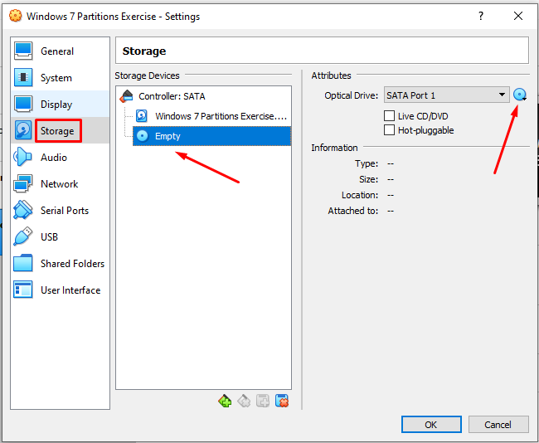

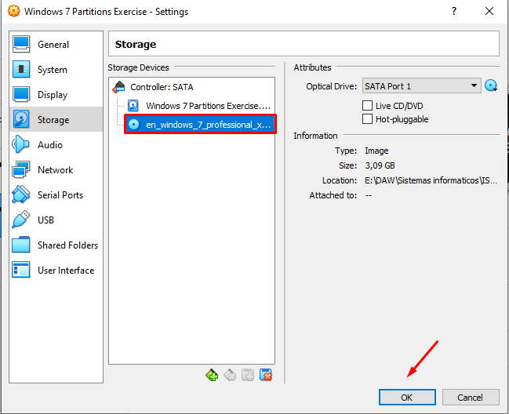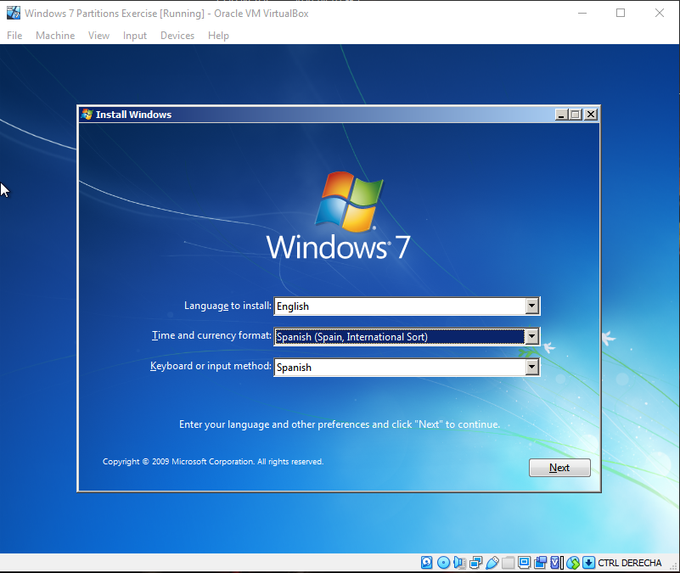

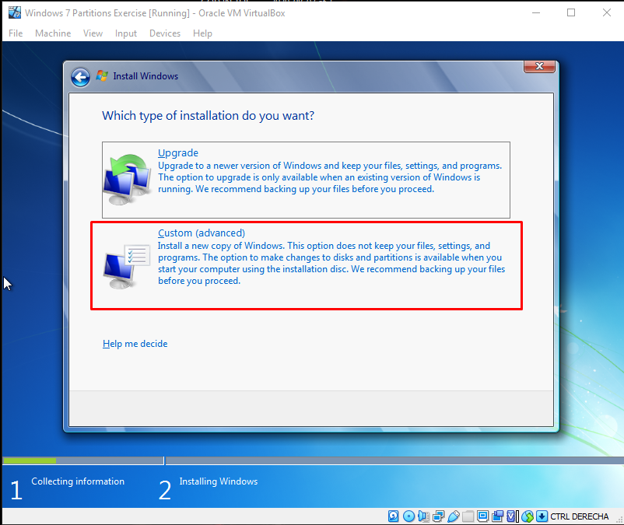

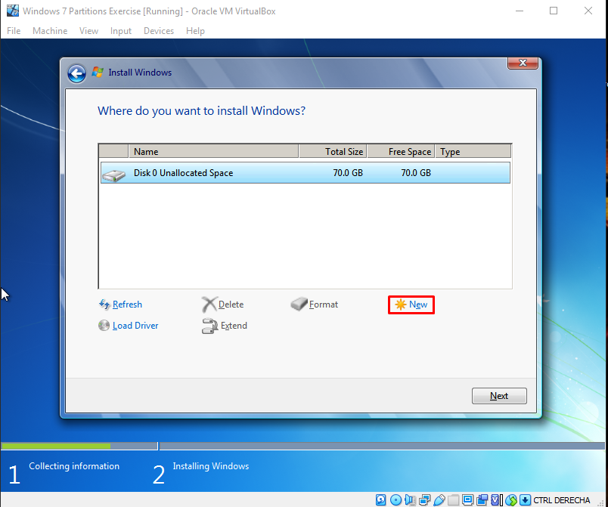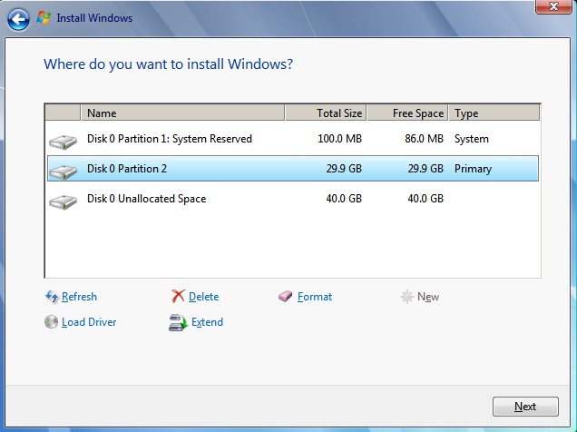

HARD DISK CREATION

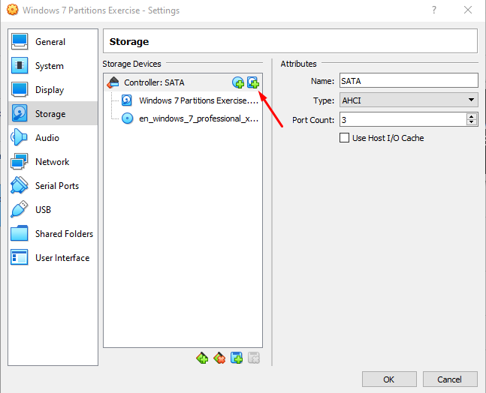

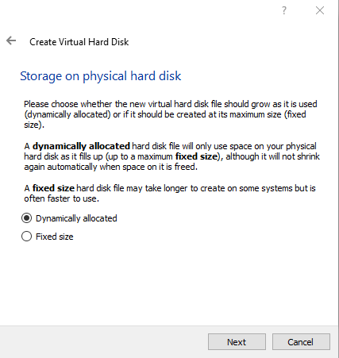 

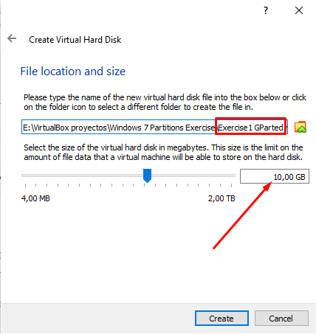

PARTITIONS:

Now we can start the exercise itself. What we need to do is replace the Windows 7 ISO file with the DRBL ISO we need to use “GParted”.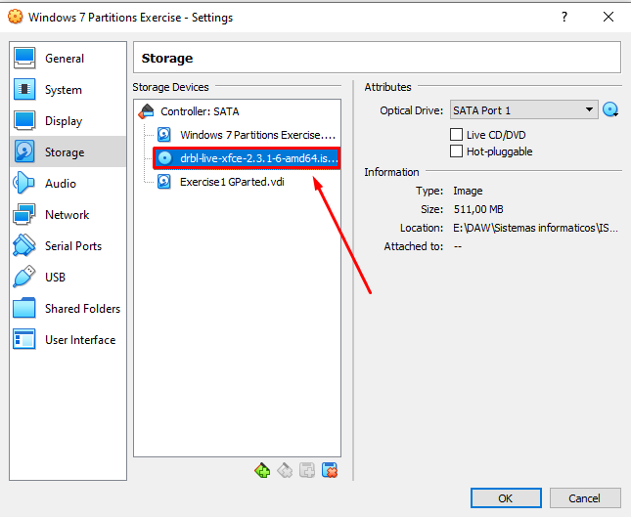

Now, when the machine is started, an interface will appear. We will not waste time explaining each option. We will just choose the next configurations by pressing “Enter”. We will choose: “Default settings”, “English” and “Don’t touch keymap”.

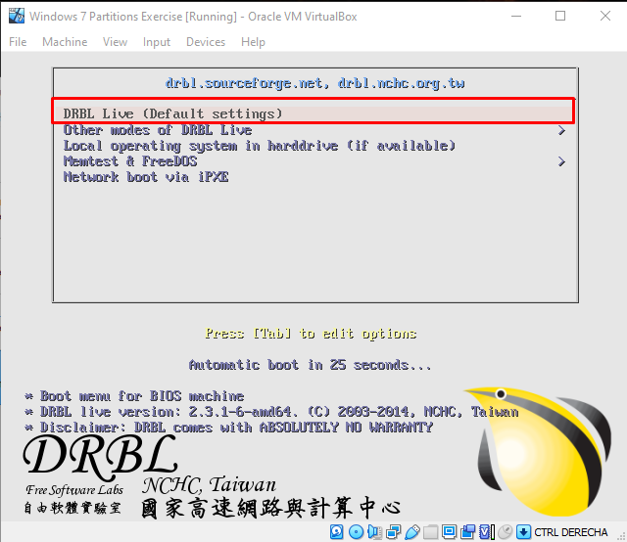

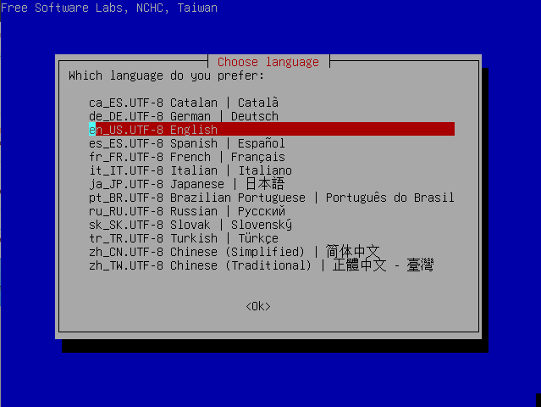

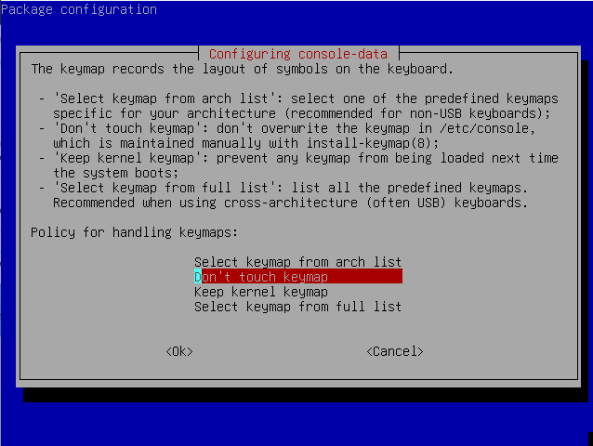

After this, a command line interface (picture below) will appear, and the only thing we need to do is press “1” to select a resolution (by typing its number, the 7th is recommended, so we would just type “7”). Then we will just press “Enter” to set default configurations.

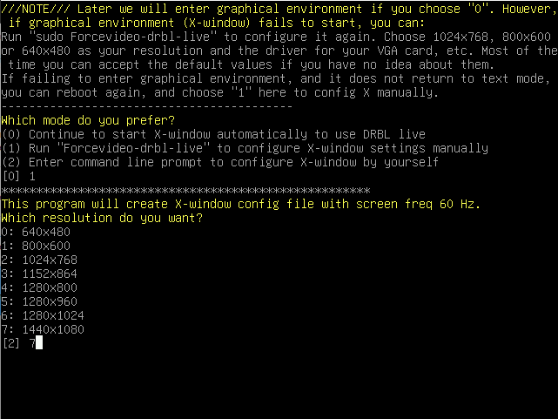

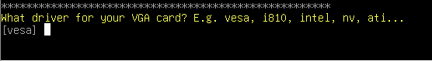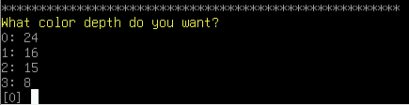

Then, the DRBL will appear. We need to open “GParted”.

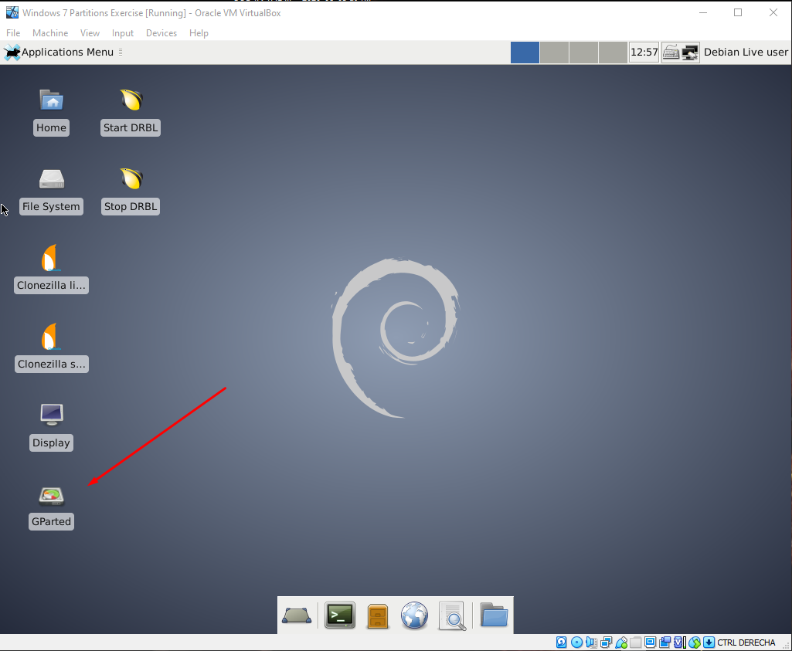

First of all, we must check which hard disk is selected, as we need to make partitions in the 10GB disk, shown in GParted as “sdb”. Then we need to go to “Device”, choose “Create Partition Table” and be sure we are working with “msdos” (MBR).

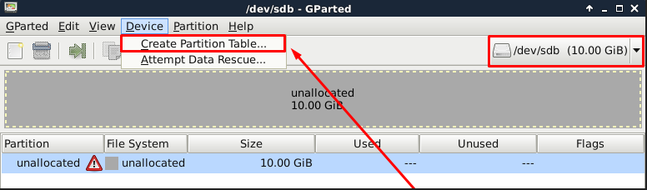

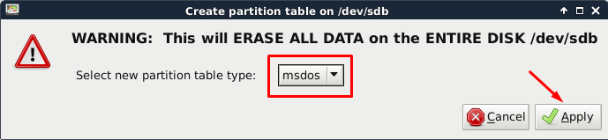

From now on, we have to click on “unallocated” to create every partition we want, as this is the empty space we have in our disk.

The first one will be an NTFS primary partition of 2GB, called PNTFS.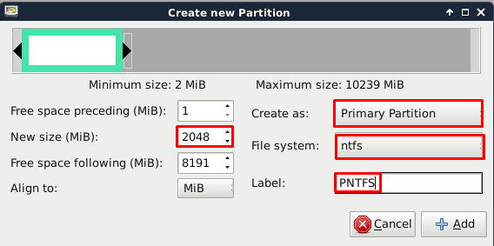

The second one will be an EXT4 primary partition of 2GB, called PEXT4.

→ This partition will not be recognized by Windows, as EXT4 is a file system related with Linux.

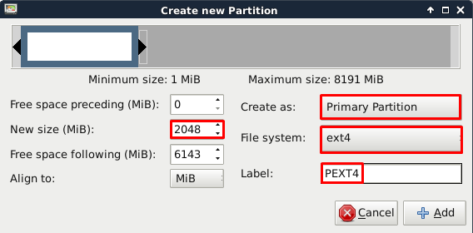

The third one will be an extended one, so it will not have a file system (neither a name, as it will not be shown). It will be 4GB in total, but 2 of them will be kept for the last partition, which will be logical (as it is inside the extended one), with FAT32 as file system and will be called PFAT32.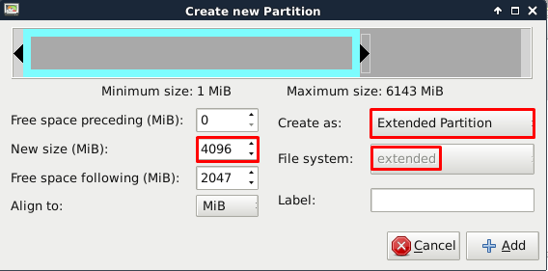

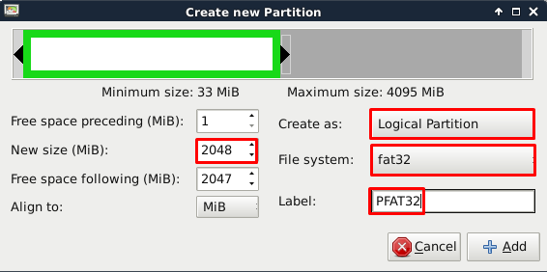

When all the partitions are done, this is how they must appear in GParted. If it is correct, go to the check symbol (✅) in the upper side of the window and confirm your partitions.

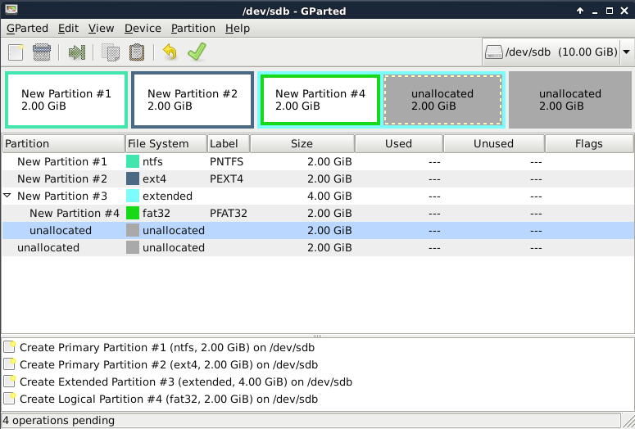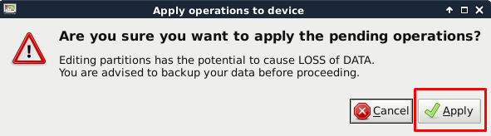

Now we have to turn down the machine, go to its settings, go to “Storage” and change the ISO file again, from DRBL back to Windows 7.

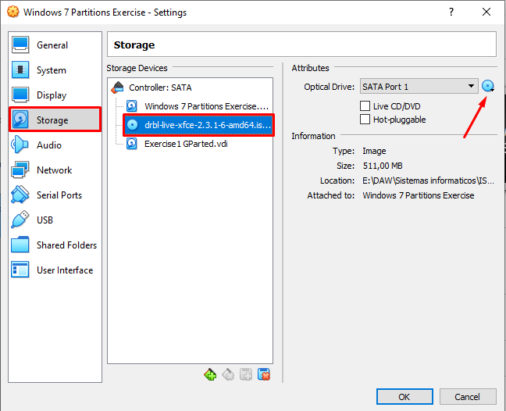

Finally, when we change the ISO file, we need to start our machine. Then, when it is ready to work, we have to go to the windows menu, write “Disk management” and click on “Create and format hard disk partitions” to see if all of them are correct.

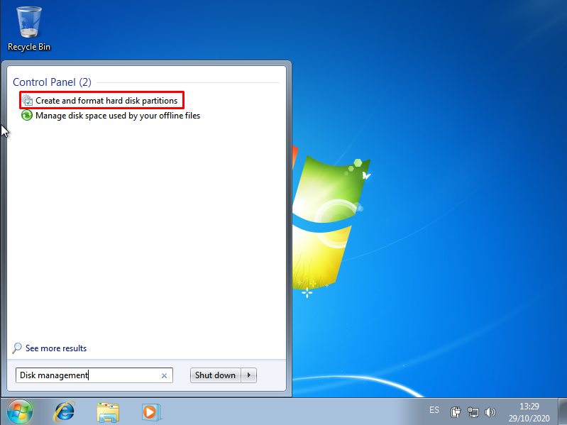

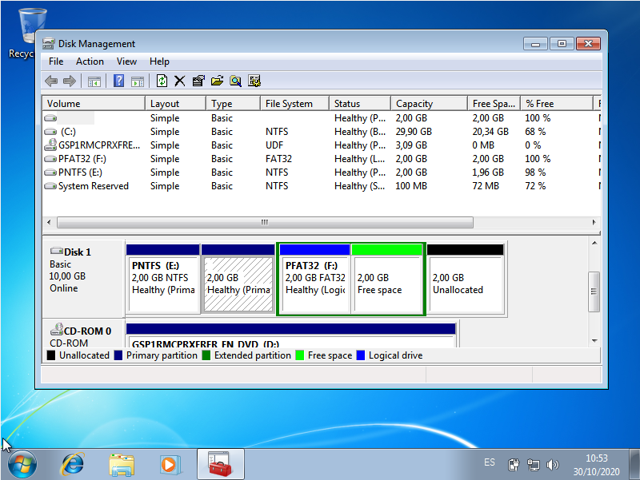

If your table is like this, you have finished with your partitions!

Questions:

* Why is the file system not shown in the second partition?
  + As we said before, this happens because it is an EXT4 file system, used in Linux, not Windows.
* If you had to create a new partition to store 2GBof data, where would you put the partition in? Which file system should we use? Justify your answer.
  + I would recommend to store it in the empty space from the logical partition we did before, as logical partitions are dynamic, meaning more flexible and more adaptable if any changes do take place.

**ALFREDO PUERTA GALLEGO DW1E**